**4B OS LAB-08 ASSIGNMENT**

# **Muhammad Danish | cs182019 | 4B**

**Question 01:**

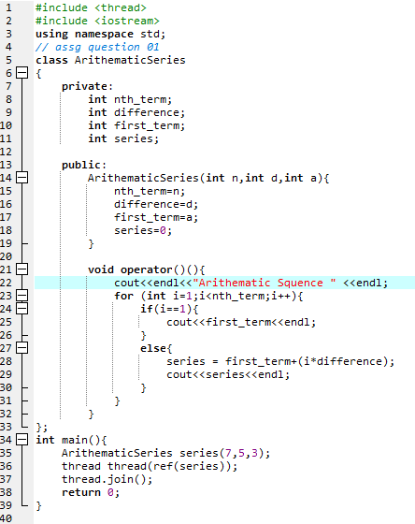

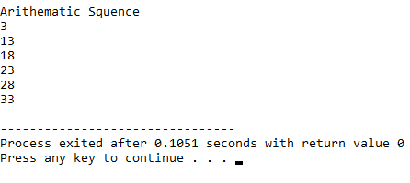

**Question 02:**

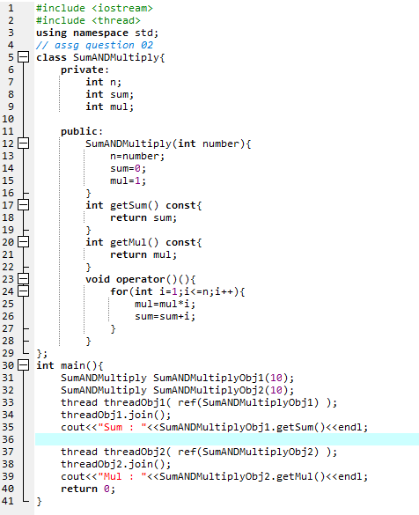

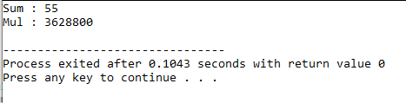

# **Muhammad Danish | cs182019 | 4B**